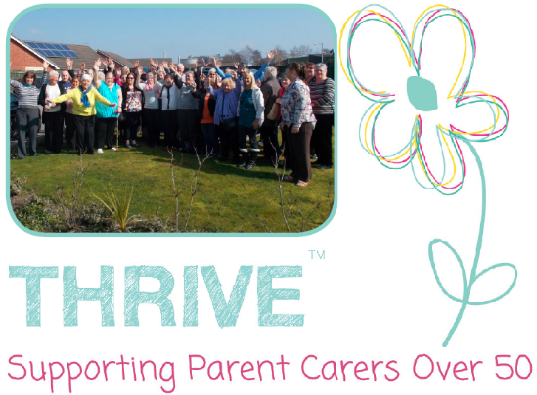
Job Description
Job Title:  Thrive Support Worker | Perm/Contract:  Up to 3 year contract | Reports to:  Thrive Service Coordinator
Based at:  Talbot House / Work from home | Hours:  27.5 hours per week | Salary:  £15,015 / £10.50 per hour

About Us

At Talbot House we provide vital support services for parents and unpaid carers of people with severe learning disabilities and complex needs who live in the Manchester area, delivered from our building in Newton Heath. We operate a user-led one-stop-shop service that has supported parents and carers of all age ranges and ethnic backgrounds for over 40 years (founded 1976). Our motto is “We begin, middle and end it” as Talbot House is there for parents and carers every step of the way. Our goal is to provide essential support and be an advocate for our carers in getting the correct benefits, finding care services, help with form filling/letter writing, training for carers, along with the mental health and wellbeing support that many carers of learning disabled people desperately need.

About the Role

We are looking to recruit a dedicated and passionate person to join our expanded Thrive support team. Our Thrive service was started 6 years ago with the goal to encourage older parent carers to plan for the future when it comes to caring for their learning disabled child, and to “Watch them thrive while I’m alive”. We found from our staff and volunteers personal experience, and carer feedback, that as they, and their cared-for gets older they often find they start to struggle with the physical, mental and emotional demands that come with looking after a learning disabled person. Along with the distress of knowing that they will one day no longer be able to perform their caring duties when they are either physically or mentally incapable, or when they sadly pass away, and how this will impact the wellbeing of their disabled child. This new support worker will have an important role to play in supporting our older parent carers and help them plan in a positive way for the future. You will be a dynamic team player with a real understanding of and empathy for older parent carers who have devoted a lifetime to caring for their child. This is a challenging role which will require you to have excellent communication and empathetic skills, and be able to demonstrate patience, tact and sensitivity. You will need good knowledge of the demands that come with caring for a learning disabled person and of the caring services and benefit systems that exist. The key objectives of the Thrive project are;
- To begin a conversation with older parent cares, “What happens to my child in the future when I am no longer able to care for them”
- To raise awareness amongst older parent carers of the support available to them. Provide a safe and supportive environment where they can discuss their concerns about the future and explore solutions at their own pace.
- To offer timely and appropriate information and advice, and where needed/appropriate ensure that support is in place at time of crisis.
- To support older parent carers to develop a flexible and realistic plan for the future – this may include financial planning, creating wills, funeral planning, support arrangements for the cared for and carer etc.

Main Duties

- Supporting older parent carers at Talbot House and at external appointments as required.
- Provide one to one support and advice.
- Write professional applications and reports for a variety of agencies.
- Research and utilise other support services beneficial to service users.
- Build productive working relationships with staff, volunteers and external organisations.
- Work with the Thrive coordinator and Talbot House staff to improve our service user experience.
- To publicise the Thrive project and raise awareness.
- Support and take part in carer activities and events undertaken by Talbot House to promote carer wellbeing.
- Assist with the supervision of volunteers.
- Keep accurate records and ensure database is kept up to date, along with other IT systems.
- To undertake any other duties reasonably requested by the Manager.

Funding and Contract
This job vacancy is possible due to the fantastic support provided by The National Lottery. This is entirely funded by The National Lottery Community Fund for next 3 years starting from the 10th August 2021. The success of this project is reviewed after the first 6 months, and then every 12 months thereafter. Therefore contracts are on that basis.
Closing date for application = Friday 25th June 2021

Person Specification

 | Essential | Desirable | Method of Assessment
Education/ qualifications  Training | None | - Evidence of previous relevant training  - Advocacy or advice training | Application form
Knowledge and Experience | - Evidence of knowledge and experience of challenges faced by parent carers as they age  - Broad understanding of learning disabilities and learning disability services  - Knowledge and understanding of diversity and equality issues | - Experience of supporting parent carers.  - Previous experience in a similar role.  - Lived experience of caring. | Interview & application form
Skills and aptitude | - Effective IT skills using databases, Word, Excel etc.  - Evidence of strong organisational skills  - Ability to manage own time and workload  - Excellent verbal and written communication skills  - Ability to demonstrate patience tact and empathy  - Ability to work with a broad range of people.  - Willingness to undertake training appropriate to the role.  - Ability to work flexibly. | - Good knowledge and experience using social media platforms.  - Good presentation skills to promote service. | Interview & application form

